

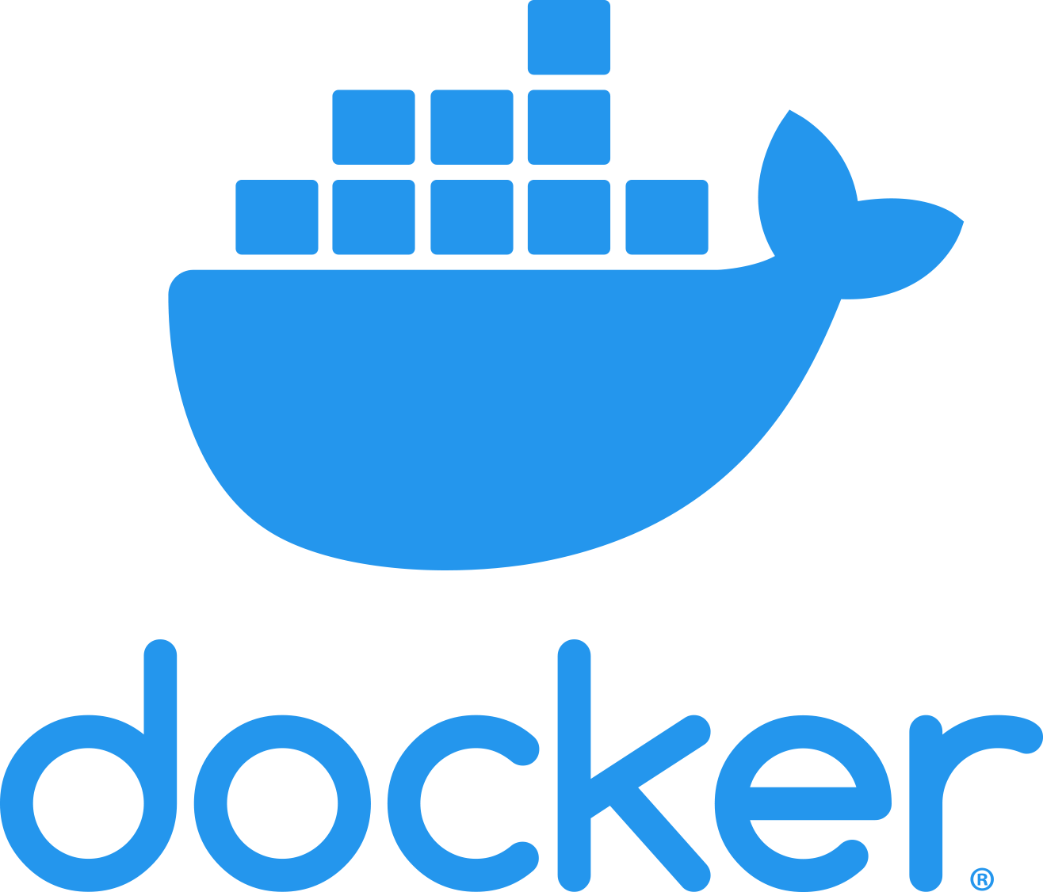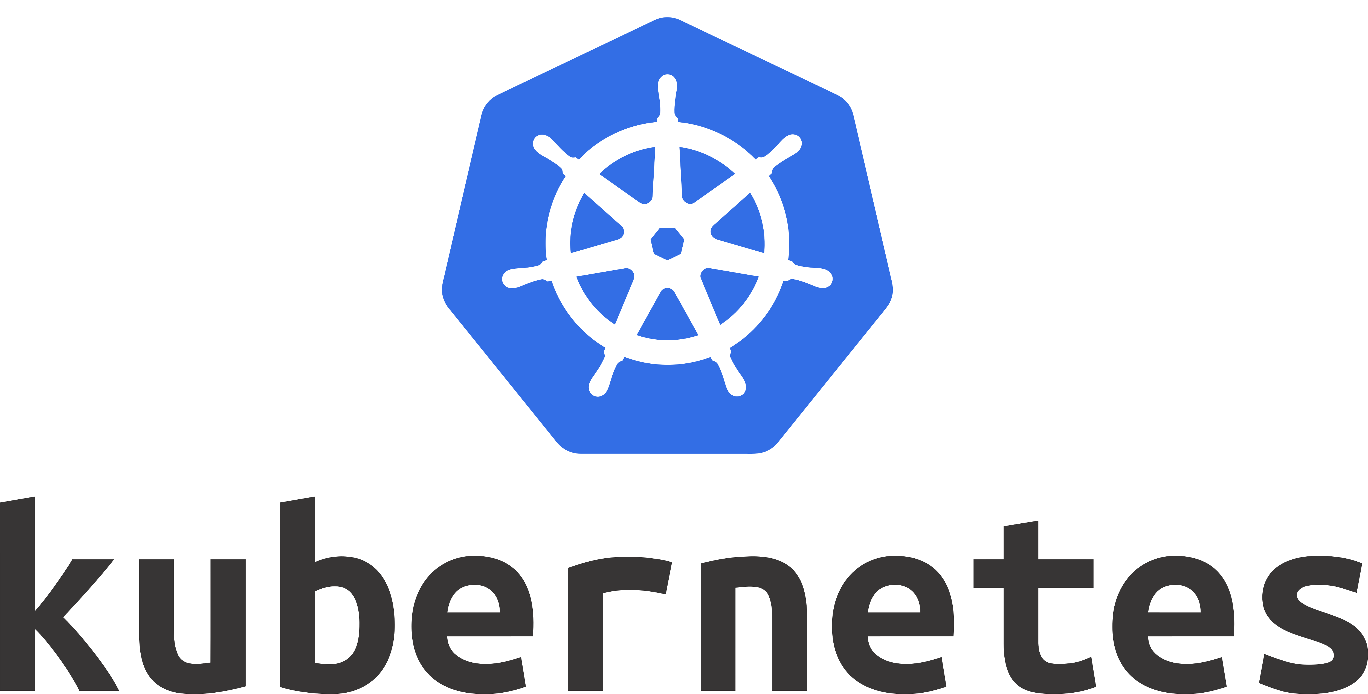

**Introduction to Docker**

**Installation and Configuration**

* CE & EE
* Installing Docker on CentOS
* Installing Docker on Ubuntu
* Storage Driver
* Running a Container
* Upgrade the Docker Engine
* Configuring Logging Drivers

**Introduction to Docker Swarm**

* Swarm Working Model
* Configuring a Swarm Manager
* Configuring Swarm Nodes
* Backup and Restore

**Namespaces and cgroups**

**Container Management**

* Launching Containers
* Container Commands

I**mage Creation, Management, and Registry**

* Introduction to Docker Images
* Dockerfile
* Dockerfile Directives
* Building Efficient Images
* Image history
* Flattening a Docker Image
* Docker Registries
* Using Docker Registries
* Using docker inspect

**Orchestration**

* Locking &Unlocking a Swarm
* High Availability in a Swarm
* Introduction to Docker Services
* Docker Compose
* Introduction to Docker Stacks
* Labels and Constraints

**Storage and Volumes**

* Docker Storage
* Configuring DeviceMapper
* Docker Volumes
* Bind Mounts
* Image Cleanup
* Storage in a Cluster

**Networking**

* Docker Networking
* Built-In Network Drivers
* Creating a Docker Bridge Network
* Deploying a Service on a Docker Overlay Network

**Security**

* Signing Images and Docker Content Trust
* Default Docker Engine Security
* Securing the Docker Daemon

**Docker EE**

* Installing Docker EE
* Universal Control Plane (UCP)
* Security in UCP
* Docker Trusted Registry (DTR)
* Configuring Backups for UCP and DTR
* DTR Security
* Managing Certificates with UCP and DTR

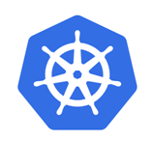

**Kubernetes Platform**

* Comparison with Docker Swarm
* Orchestration and Various Tools
* History of Kubernetes

**Introduction**

* Kubernetes Terminology
* Kubernetes Architecture
* Kubernetes Cluster Architecture
* Kubernetes API Primitives
* Kubernetes Services and Network Primitives

**Kubernetes Setup and Validation**

* Building the Kubernetes Cluster on Ubuntu
* Release Binaries, Provisioning and Types of Clusters
* Installing Kubernetes Master and Nodes
* Building a Highly Available Kubernetes Cluster
* Configuring Secure Cluster Communications
* Testing The Cluster

**Managing Cluster**

Managing the Kubernetes Cluster

* Upgrading the Kubernetes Cluster
* Backing Up and Restoring a Kubernetes Cluster

**Networking**

* Cluster Communications
* Pod and Node Networking
* Container Network Interface (CNI)
* Service Networking
* Ingress Rules and Load Balancers
* Cluster DNS

**Scheduling**

* Pod Scheduling within the Kubernetes Cluster
* Configuring the Kubernetes Scheduler
* Running Multiple Schedulers for Multiple Pods
* Scheduling Pods with Resource Limits and Label Selectors
* DaemonSets and Manually Scheduled Pods
* Displaying Scheduler Events

**Application Lifecycle Management**

* Deploying Applications in the Kubernetes Cluster
* Deploying an Application, Rolling Updates, and Rollbacks
* Configuring an Application for High Availability and Scale
* Creating a Self-Healing Application

**Storage**

* Managing Data in the Kubernetes Cluster
* Persistent Volumes
* Volume Access Modes
* Persistent Volume Claims
* Applications with Persistent Storage

**Security**

* Securing the Kubernetes Cluster
* Kubernetes Security Primitives
* Cluster Authentication and Authorization
* Creating TLS Certificates

**Logging and Monitoring**

**Troubleshooting**